Project Design Phase-II
Data Flow Diagram & User Stories

Date | 30 September 2026
Team ID | SWTID-2026-9545
Project Name | Import Data using Transform Maps (Spreadsheet) – ServiceNow
Maximum Marks | 4 Marks

Data Flow Diagrams:
A Data Flow Diagram (DFD) is a visual representation of the information flows within a system. It shows how data enters and leaves the system, what changes the information, and where data is stored.
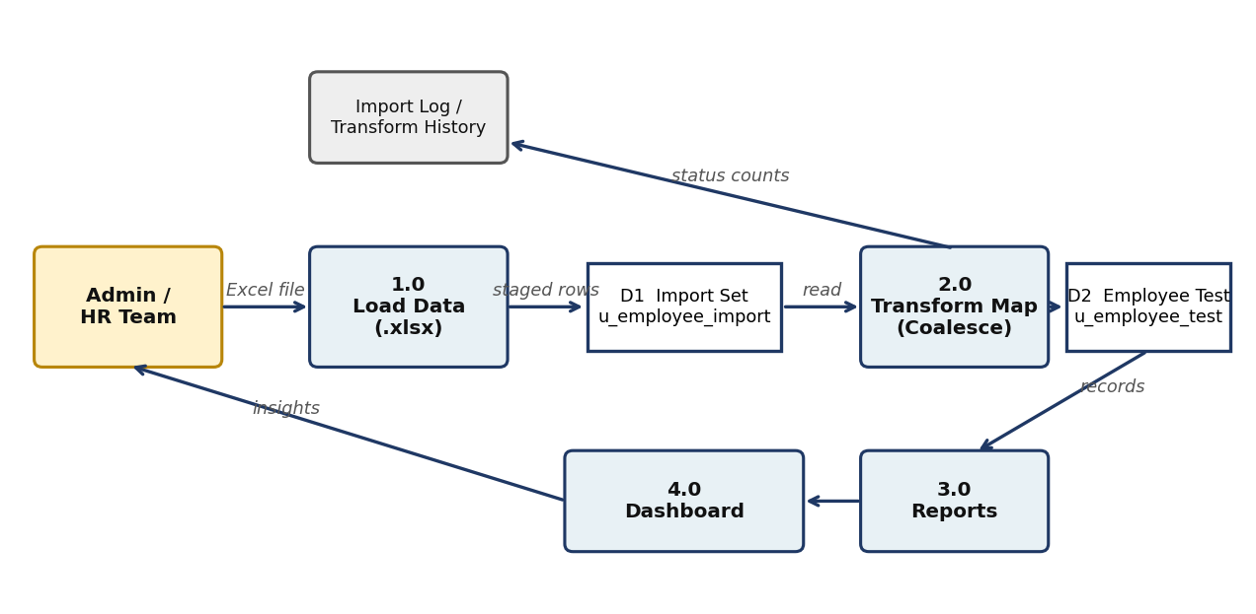
Figure 1: Data flow – spreadsheet to Import Set, Transform Map, target table, reports and dashboard
User Stories
User Type | Functional Requirement (Epic) | User Story Number | User Story / Task | Acceptance criteria | Priority | Release
Administrator | Data Preparation | USN-1 | As an administrator, I can prepare an employee spreadsheet and download it as .xlsx. | File “Sample Spreadsheet.xlsx” is available with 15 rows | High | Sprint-1
 | Target Table | USN-2 | As an administrator, I can create the Employee Test custom table. | Table u_employee_test exists | High | Sprint-1
 |  | USN-3 | As an administrator, I can add Employee ID, Name, Email, Department and Location fields. | Fields show on the form | High | Sprint-1
 | Data Import | USN-4 | As an administrator, I can load the spreadsheet into an Import Set table. | Load shows Complete / Success, 15 inserts | High | Sprint-1
 |  | USN-5 | As an administrator, I can create a Transform Map from the import table to the target table. | Five field maps are visible | High | Sprint-1
 |  | USN-6 | As an administrator, I can run the transform and view records. | 15 records in Employee Tests | High | Sprint-1
 | Duplicate Prevention | USN-7 | As an administrator, I can coalesce on Employee ID. | Coalesce = true on u_employee_id | High | Sprint-2
 |  | USN-8 | As an administrator, I can re-import changed data and see updates instead of duplicates. | 2 inserts and 2 updates; repeat gives 4 ignored | High | Sprint-2
 | Reporting | USN-9 | As an administrator, I can create a pie chart of employees by department. | Pie shows department counts | Medium | Sprint-2
 |  | USN-10 | As an administrator, I can create a bar chart of employees by location. | Bar shows Hyderabad and Chennai | Medium | Sprint-2
 |  | USN-11 | As an administrator, I can create a list report of employees. | List shows all 17 rows | Medium | Sprint-2
 | Dashboard | USN-12 | As an administrator, I can create the Employee Analytics Dashboard. | Dashboard record saved | Medium | Sprint-2
HR Team (Viewer) |  | USN-13 | As an HR team member, I can view all three reports on one dashboard. | Dashboard shows three widgets | Medium | Sprint-2

